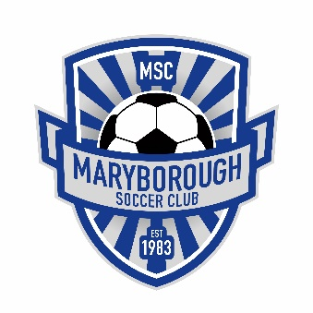
Maryborough SC Registration Fees 2020

Maryborough Soccer League (Local)
All Age Groups from Under 7’s-Under 17’s Volunteer Discounted Rate:
1 Player: $95.00 $80.00
2 Players: $180.00 $160.00
3 Players: $255.00 $240.00
4 Players: $330.00 $320.00
*Volunteer applicants must be approved by the MSC Committee

BDSA (Regional)
Seniors: Standard Registration fee: (18+)
$300.00 per player
Volunteer Discounted Rate: $240.00
For those playing seniors under the age of 18:
$250.00 per player (BDSA only)
Volunteer Discounted Rate: $200.00
Juniors: Standard Registration fee: (Under 15’s)
$150.00 per player (BDSA only)
Volunteer Discounted Rate: $120.00
Flexible Fee Structure benefits to Seniors & Under 15’s :
*Volunteer applicants must be approved by the MSC Committee

Payment plans are available but must be discussed with our club Treasurer first with a deposit to be paid before the plan begins.

