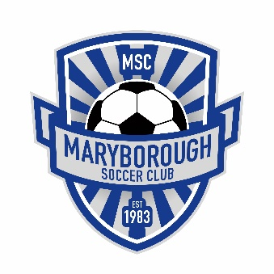
Maryborough SC Registration Fees 2021

Maryborough Soccer League (Local)
All Age Groups from Under 7’s-Under 17’s
1 Player: $85.00
2 Players: $160.00
3 Players: $230.00
4 Players: $290.00

BDSA (Regional)
Seniors: Standard Registration fee: (18+)
$250.00
For those playing seniors under the age of 18:
$200.00
Juniors: Standard Registration fee: (Under 15’s)
$150.00 per player (BDSA only)
Volunteer Discounted Rate: $120.00
*Volunteer applicants must be approved by the MSC Committee

Payment plans are available but must be discussed with our club Treasurer first with a deposit to be paid before the plan begins.

