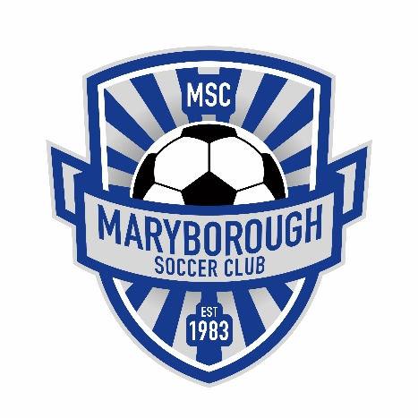
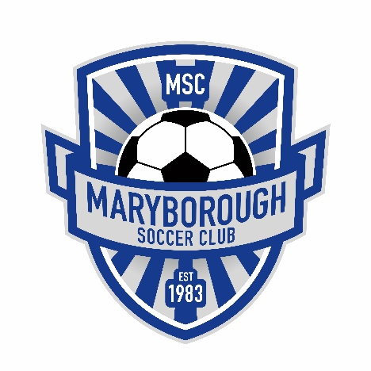
Maryborough Soccer Club
Registration FAQ

Q: How much is Rego in 2021?
A: Saturday Competition Under 7’s through to Under 17’s: 1 child = $85, 2 = Children $160, 3 Children = $230 and 4 Children = $290
BDSA Seniors: Over 18’s = $250, Under 18’s = $200, Under 15’s = $150.00
Volunteer discounts are available and are to be approved by the MSC committee – please contact us for further information.
Q: When can we register?
A: Registrations are open right now, you can simply go online at this website: https://www.playfootball.com.au/register
Follow the prompts, select the appropriate ‘Maryborough SC’ package, pay online and then you’re all set for the start of the season.
Q: What if I am having trouble registering online?
A: If you are having issues with the registration process, we are here to help! Just come down to our registration dates and we will have laptops set up with volunteers to help guide you through the process.
The 2021 dates are:
Saturday April 10thth at the Maryborough Soccer Fields (Park Rd) from 10am-12pm
Wednesday April 21st at the Maryborough Soccer Fields (Park Rd) from 4pm-6pm
If you can’t make these dates and still need some help, please email us: maryboroughsoccer@gmail.com
Q: What are the age groups for the Saturday competition in 2021?
A: Under 7’s, Under 9’s, Under 13’s and Under 17’s.
Q: When does registration need to be completed by?
A: This year we have set the date for all registrations for the 2020 season to be completed by April 22nd.
Q: When does the season start?
A: Saturday March 24th. Please save the date!
Q: What do I need to bring to registration day?
A: You will need access to an email address and if you have registered your child before you will need your password from that past registration or an email to recover the password.

